Project FUSION

Trial learnings report:

Primacy Rules Implementation

*División negocio*

Date of document 09.03.2023

Contents

**1.** Introduction 3

**1.1.** Purpose of this document 3

**1.2.** Overview of Project FUSION 3

**2.** Executive summary 4

**3.** Background 5

**3.1.** Impetus for trial 5

**3.2.** Open Networks Project 5

**3.3.** Primacy – an introduction 7

**3.4.** Trial optioneering 8

**4.** Trial design 12

**4.1.** Scope & Process 12

**4.2.** Communication protocol 13

**4.3.** Deliverables & Timescale 13

**5.** Trial delivery 14

**5.1.** BMU Data Transfer (NGESO) 14

**5.2.** BMU Mapping (SP ENERGY NETWORKS) 16

**5.3.** Risk of Conflict Reporting (SP ENERGY NETWORKS) 23

**5.4.** Downstream ESO process (NGESO) 26

**6.** Analysis 28

**7.** BaU Implementation: Considerations for DNO 30

**8.** Conclusion 33

**9.** Glossary 35

**10.** Appendix 1 – USEF Overview 36

**11.** Appendix 2 – Balancing mechanism flow diagrams 37

**12.** Appendix 3 – ESO Downstream Process 39

**13.** Appendix 4 – Roc Reporting Protocol 40

**14.** Appendix 5 – Roc Reporting Template 41

1. Introduction
   1. Purpose of this document

This document seeks to report on the findings of the ‘primacy rules’ trial in which SP Energy Networks (Project FUSION) and National Grid ESO (NGESO) collaborated between Nov 2022 and Jan 2023.

This document provides an overview of the:

* Historical context leading up to the trial
* Scope and objectives of the trial
* Learnings from the trial
* Recommendations for next steps
  1. Overview of Project FUSION

[Project FUSION](https://www.spenergynetworks.co.uk/pages/fusion.aspx) is funded under Ofgem’s 2017 Network Innovation Competition (NIC), to be delivered by SP Energy Networks.

Project FUSION is a demonstration of SP Energy Network’s commitment to transitioning to becoming a Distribution System Operator, taking a step towards a clean, smart and efficient energy system. As the electricity system changes from a centralised to decentralised model, it enables the functioning of a smarter and more flexible network.

Project FUSION is trialling the use of commoditised local demand-side flexibility through a structured and competitive market, based on a universal, standardised market-based framework; the Universal Smart Energy Framework (USEF). The purpose of USEF is to accelerate the transition to a smart, flexible energy system to maximise benefits for current and future customers. More information on USEF is provided in Appendix 1.

FUSION findings may also inform wider policy developments around flexibility markets and the DNO-DSO transition through the development and testing of standardised industry specifications, processes, and requirements for transparent information exchange between market participants accessing market-based flexibility services.

Ultimately, FUSION is an innovation project, and its findings will contribute to all Distribution Network Operators and market actors unlocking potential and value of local network flexibility in a competitive and transparent manner, regardless of the end-solution or adoption of USEF.

In providing this vital service, FUSION aims to contribute to addressing the energy trilemma by making the energy system more secure, affordable and sustainable.

# Executive summary

|  |  |
| --- | --- |
| Use case trialled: Balancing Mechanism (BM) vs DNO Flexibility | |
| Primacy rule trialled: BM1a | |
| Stage | **Learnings from each stage of the process** |
| BMU data transfer (ESO) | * The Balancing Mechanism Unit (BMU) data transfer provided to SP Energy Networks lacked reliable, hi-resolution geospatial data. * The BMU data had been collated from various disparate sources within the ESO. |
| BMU mapping (DNO) | * The lack of reliable geospatial data within the BMU data transfer made the mapping process heavily reliant upon human input to manually associate BMUs with DNO congestion points. This made the mapping process:   + relatively laborious (manual assessment to match assets with similar names)   + relatively conservative (with a greater frequency of conflicts being identified than would necessarily have been the case had the BMU data contained higher-resolution geospatial data). * That said, the trial succeeded in mapping the BMU data and, for the first time, identified ‘risks of conflict’ which may otherwise have gone unnoticed. |
| ‘Risk of Conflict’ (RoC) reporting (DNO) | * A RoC report was successfully issued (by email) to the NGESO each Tuesday afternoon for four consecutive weeks, commencing October 19th 2022. * Those RoC reports communicated several instances of week-ahead conflicts having been identified. * Their timely communication to the NGESO demonstrates the efficacy of the BM1a rule for helping to manage the risk of this use case. |
| Downstream process (ESO) | * RoC reports were successfully received by NGESO. * Requirements for developing an enduring and scalable solution in ESO are now better understood and are being progressed. |
| Recommendations for next steps | |
| * Rule BM1b: Consider demonstrating the implementation of this rule for the same use-case and reporting on its efficacy. * BMU Data: Consider how improvements could be achieved to both availability and quality of data (particularly geospatial data). * Automation: Consider opportunities to automate the processes to facilitate scaling, and what improvements to data might be required to facilitate those enhancements. * BaU: Consider the business implications (both for ESO and DNO) of adopting this trialled approach into BaU and scaling it to accommodate the increase of flex services that we envisage in Q3 2023. * Consider the implications across the industry of poorly aligned and poor-quality data and flag for consideration if appropriate. | |

Table 1: Executive Summary

# Background

2. 1. Impetus for trial

The key factors leading to the undertaking of this trial are summarised below.

* + 1. Project FUSION

In its [project direction](https://www.ofgem.gov.uk/publications/network-innovation-competition-amended-project-direction-fusion) Project FUSION was tasked with delivering a report, in coordination with

the ENA, on hierarchies of control for flexibility. That objective aligned well with the ‘Primacy’ work being developed by the Energy Networks Association (ENA) under Workstream 1A, Product 5 of the Open Networks Project. (Refer to Section 3.3 for more information). Project FUSION therefore engaged with National Grid ESO (NGESO) to explore opportunities for collaborating on a trial to implement one of the primacy rules developed by the ENA and reporting upon its efficacy for managing a specific primacy use case.

SP Energy Networks and NGESO agreed the trial scope, which would demonstrate the implementation of Primacy Rule 1a to manage the ‘Balancing Mechanism (BM) vs DNO Flexibility’ use case.

This report, written in collaboration with NGESO and in coordination with the ENA, reports on the findings of that trial.

* + 1. Smart Systems and Flexibility Plan (SSFP)

The [Smart Systems and Flexibility Plan](https://assets.publishing.service.gov.uk/government/uploads/system/uploads/attachment_data/file/1003778/smart-systems-and-flexibility-plan-2021.pdf) (SSFP), published in 2021 by Ofgem, established the following mandate:

*“The* ***ENA Open Network*** *also needs to develop and implement a set of primacy rules to resolve service conflicts between ESO-procured and DNO-procured flexibility* ***by the beginning of RIIO-ED2****. Arrangements will need to be put in place for evaluating, reviewing, and amending principles and primacy rules when appropriate. We expect this should be supported by appropriate mechanisms for sharing real time data and operational forecasting as well as shared processes for monitoring distributed energy resources”*

Although this trial does not complete the above objective in full, it will demonstrate the successful implementation of a particular primacy rule to resolve the service conflicts between ESO-procured balancing (flexibility) and DNO-procured flexibility, and to generate and share insights that could add value in the delivery of the above objective.

* 1. Open Networks Project
     1. Energy Networks Association (ENA)

The Energy Networks Association (ENA) represents the owners and operators of licenses for the transmission and/or distribution of energy in the UK and Ireland. Their members control and maintain the critical national infrastructure that delivers these vital services into customers’ homes and businesses.

The ENA’s overriding goals are to promote UK and Ireland energy networks ensuring their networks are the safest, most reliable, most efficient and sustainable in the world. They influence decision-makers on issues that are important to their members. These include:

* Regulation and the wider representation in UK, Ireland and the rest of Europe
* Cost-efficient engineering services and related businesses for the benefit of members
* Safety, health and environment across the gas and electricity industries
* The development and deployment of smart technology
* Innovation strategy, reporting and collaboration in GB

As the voice of the energy networks sector, the ENA acts as a strategic focus and channel of communication for the industry and promote interests and good standing of the industry and provide a forum of discussion among company members.

* + 1. Open Networks Project (ONP)[1]

Britain’s energy landscape is changing, and new smart technologies are changing the way GB plc interact with the energy system. The Open Networks project is transforming the way our energy networks operate. New smart technologies are challenging the traditional way we generate, consume and manage electricity, and the energy networks are making sure that these changes benefit everyone.

ENA’s Open Networks Project is key to enabling the delivery of Net Zero by:

* opening local flexibility markets to demand response, renewable energy and new low-carbon technology and removing barriers to participation
* providing opportunities for these flexible resources to connect to our networks faster
* opening data to allow these flexible resources to identify the best locations to invest
* delivering efficiencies between the network companies to plan and operate secure, efficient networks

Open Networks is helping transition to a smart, flexible system that connects large-scale energy generation right down to the solar panels and electric vehicles installed in homes, businesses and communities right across the country. This is often referred to as the smart grid.

The Open Networks project has brought together the nine electricity grid operators in the UK and Ireland to work together to standardise customer experiences and align processes to make connecting to the networks as easy as possible and bring record amounts of renewable distributed energy resources, like wind and solar panels, to the local electricity grid.

The pace of change Open Networks is delivering is unprecedented in the industry, and to make sure the transformation of the networks becomes a reality, it has created six workstreams under Open Networks to progress the delivery of the smart grid.

**2021 Open Networks Project Workstreams**

* WS1A: Flexibility Services (*under which the Primacy activity sits*)
* WS1B: Whole Electricity System Planning and T/D Data Exchange
* WS2: Customer Information Provision and Connections
* WS3: DNO Transition
* WS4: Whole Energy Systems
* WS5: Communications and Stakeholder Engagement

* 1. Primacy – an introduction

Primacy generally focusses on the conflict between different assets within the same electrical network. How providers manage participation in multiple services at the same time is generally determined by Stackability rules. [2]

The ESO and DNOs manage their respective transmission and distribution networks in accordance with applicable standards and licence conditions. Each organisation may need to procure one or more services for this purpose.

Conflicts between one or more of these services can lead to inefficiencies within the whole electricity system, or inadvertently create system constraint, security or stability issues on the adjacent system.

. The risk of conflicts is likely to increase given the rising procurement of services and limited need for coordination to date. In order to manage this potential service conflict and to enable networks to be optimised efficiently and transparently, there is a need to develop a set of clear principles and “primacy” rules. These will enable procurement, planning, scheduling and dispatch of services to be influenced by whole system value and ensure that the division between market/price-driven actions and the electricity system hierarchy of operational needs is clear and transparent.

These rules will look to balance: the local networks’ technical requirements; the risks to the overall operability of the whole system; the value for Service Providers through the facilitation of market / price driven actions; the needs of emerging market-based platform developers; and ultimately the overall cost impact on end consumers.

* 2. Trial optioneering
     1. Use case

The ENA Open Networks product group recommended that the trial should aim to demonstrate the implementation of a primacy rule to manage the ‘Balancing Mechanism vs DNO Flexibility’ use case.

The core role of NGESO is to operate the GB electricity network to ensure that supply and demand are continually balanced, and that power is able to flow across the network reliably and safely.

In order to deliver the core elements of the ESO’s role, there is a reliance on service providers to help balance the overall system and ensure specific operability challenges can be resolved. While Forward Markets resolve energy requirements in advance and to a half-hourly resolution, the Balancing Mechanism (BM) enables the ESO to balance the system in real time on a minute-by-minute basis – an illustration of current market timeframes is provided in ***Figure 1*** below:

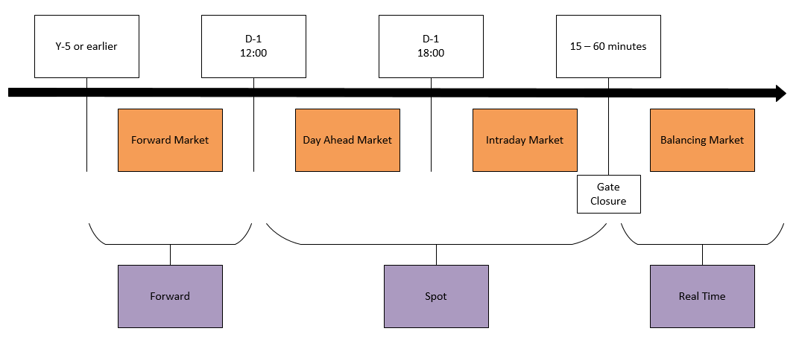

Figure 1: Market timeframes

 The Balancing Mechanism is therefore used by NGESO to balance electricity supply and demand close to real-time. This is similar to market arrangements in other countries where comparable mechanisms are used to balance the system post gate closure.

The key operating parameters and requirements for Balancing Mechanism participants are highlighted across several industry codes, including the Balancing and Settlement Code (BSC) and the Grid Code (GC). These codes define the information and data that should be submitted to NGESO, across various timescales, to declare the Balancing Mechanism Units market position and its ability to deviate from this, following an instruction from NGESO. The operation of the BM is heavily reliant on the flow of defined data between NGESO and market participants and vice versa, with much of this data being exchanged close to real-time.

As part of the key information supplied through the BM, Balancing Mechanism Units (BMUs) are required to submit Final Physical Notifications (FPNs) ahead of gate closure – this indicates the final position of each BMUs output for each half hour period. In addition, the BMU must also submit further information that enables the ESO to instruct a unit to deviate from its FPN for the reasons noted above.

Within the BM, there are a number of reasons why NGESO may need to alter the output of a BMU – these can broadly be split into ‘System’ and ‘Energy’ actions. The former seeks to instruct units to manage specific system needs (e.g., maintaining transmission network flows within pre-defined constraint limits) and the latter would issue an instruction to alter the active power output of a BMU to maintain overall energy balance.

NGESO generally carries out the role of ‘residual energy balancer’ for the GB market, with the vast majority of overall energy requirements being met by market activity ahead of real-time. Changes in the outturn of actual national demand, plant failure and weather-related events are some of the reasons why NGESO may need to intervene and re-balance the system closer to real-time.

NGESO publishes regular information (in addition to the close-to-real-time data published by Elexon) in the form of the Monthly Balancing Services Statement.[3]

The ENA Open Networks product team proposed the following areas to investigate further with regard to the deployment of Primacy Rules:

* Voltage Management
* Thermal Constraints
* System Inertia Instructions

Further work has also been carried out to highlight some of the core elements of the ESOs current processes, to ascertain where the deployment of new Primacy Rules will ultimately fit in. Given the work completed already under the Transmission Constraint Management (TCM) Use Case, it is highly likely that similar Rules could apply, however the deliverability of changes to existing BM processes and systems will need to be considered throughout the next stage of work.

*Appendix 2 – 'ESO flow diagrams’* illustrates how the ESO manages voltage fluctuations, system inertia and import constraints.

* + 1. Primacy rule

The BM Use Cases have many similarities with the Transmission Constraint Management (TCM) and DNO service use case also being progressed by the ENA Open Networks product group.

***Figure 2*** below illustrates a possible scenario in which the ESO attempts to reduce the export of a single/multiple generator(s) to manage a TCM Constraint when, at the same time, the DNO attempts to procure a Generation Turn Up (GTU)) / Demand Turn Down (DTD) service from different assets in the same local area, thus creating a conflict and offsetting of actual versus intended outcomes.

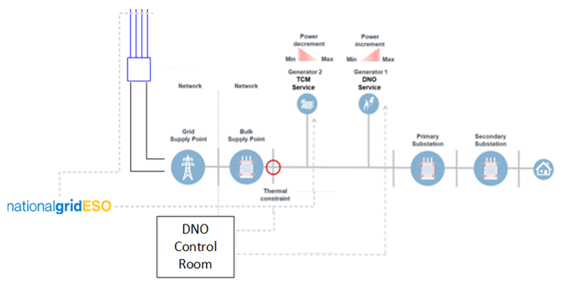

Figure 2: Illustration of the 'TCM service vs DNO service' use case.

In both the BM and TCM use cases there is no option to allow the ESO priority, due to the DNOs geographic limitations, and so the rules available focus on DNO priority and the various ways of exchanging data to support them.

As such the ENA Open Networks product group recommended that the trial of the BM use case should employ a simple DNO priority rule known as Rule 1. The rule carries 2 variants, Rule 1a and Rule 1b – detailed in the table below.

|  |  |  |
| --- | --- | --- |
| Use case: ‘Voltage Management, Thermal Constraint & System Inertia Instructions in the Balancing Mechanism vs DNO Active Power Flexibility Services except Restore’ | | |
| Rule 1: DNO Priority | **Variant A** | **Variant B** |
| DNO priority - information shared ahead of time.  (The DNO shares a weekly ‘Risk of Conflict’ [RoC] report with the ESO). | DNO priority – closer to real time information sharing.  (In development) |

Table 2:Available rules for managing the ‘BM vs DNO flex’ use case.

The processes associated with the rules developed are illustrated in the flow charts below in the context of the TCM use case[4]. They’re intended to illustrate how the same principle could be applied to the BM use case. Specific constraints on the DNO network are referred to in those flow charts as ‘Constraint Management Zones’ (CMZ).



Figure 3: Rule 1a (illustrated using the TCM use case)



Figure 4: Rule 1b (illustrated using the TCM use case)

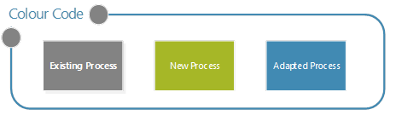

1. Trial design
2. 1. Scope & Process
      1. Use case & primacy rule

The scope of this trial was to demonstrate the implementation of a primacy rule ‘BM1a’ to address the ‘Balancing Mechanism (BM) vs DNO Flexibility’ use case.

* + 1. Process

The basic process that was trialled is illustrated below:

* 1. Communication protocol

The ENA shared the following guidelines to prescribe the communications protocol between NGESO and SP Energy Networks

* Comm’s guidance (see *Appendix 3 – Roc Reporting Protocol*)
* RoC report template (see *Appendix 4 – Roc Reporting Template*)
  1. Deliverables & Timescale

SP Energy Networks agreed to produce a written trial learnings report by Feb 2023 outlining the learnings from the trial, including the following:

* How the process prescribed in Section 4.2 were implemented.
* What difficulties / risks were encountered / perceived.
* Recommendations for next steps.

2. Trial delivery

Whilst the data exchanges between SP Energy Networks and NGESO, the timing of these exchanges and the communication protocols to be adhered to were all prescribed (see Section 4); the back-end processes that each party employs in delivering these obligations was not prescribed.

The purpose of *Section 5* is to report on the procedures that were developed by NGESO and SP Energy Networks in delivering each of the 4 steps set out in *Section 4.1.2.*

The entity referred to in each sub-heading below (i.e., NGESO or SP Energy Networks) indicates the owner of each step in the trial delivery process, and the content of each subsection reflects the trial feedback from that respective entity.

* 1. BMU Data Transfer (NGESO)

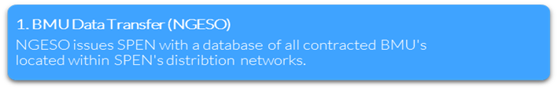

To facilitate the processes defined in Section 4.1 there is a dependency upon the DNO having a clear and accurate view of the BM Units that are embedded within their network, so addressing this challenge became the starting point for the trial.

The ENA Open Networks product group had previously agreed a specification of data items believed to be necessary or helpful in allowing the DNO to identify embedded BMUs on their networks. The data fields initially specified are listed below:

* Unique BMU ID identifier
* BM Unit Name
* GSP
* Wk24 Node
* Postcode
* Latitude (TBC – nice to have)
* Longitude (TBC – nice to have)
* Capacity (TBC – nice to have)
* Fuel Type
* MPAN / MSID (TBC – nice to have)
  + 1. Initial attempt

Initial investigations within ESO quickly revealed the absence of a single view or data source that provides access to the BMU data specified above. There were also some challenges / questions raised internally within ESO around whether the specified data was suitable for sharing with DNOs due to it relating to a contractual arrangement between ESO and generators and not an arrangement with the DNOs. As a result, ESO needed to undertake some internal assurance and also obtain confirmation from their own Legal and Compliance teams that the sharing of any BMU data was deemed to be appropriate and compliant. The outcome was that ESO assurance teams were comfortable that, provided data shared is already in the public domain, no data breaches would be made in the sharing of the above data.

An initial data extract was taken from an ESO data source entitled CRM Salesforce through which all BMU registrations are made, the relevant fields (where available in CRM) being those included for extraction. ***Figure 5*** below shows a sample of the initial CRM Salesforce extract.

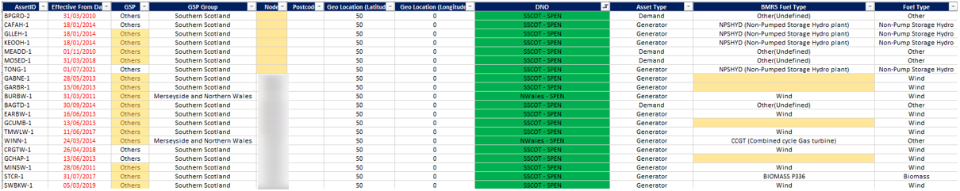

Figure 5: Initial ‘CRM salesforce’ data extract

As can be seen from the above sample, a number of the data fields originally specified were either missing data altogether or included data that appeared to be incomplete or inaccurate.

Whilst the data specified at the beginning of the exercise was originally believed to be available, deeper analysis of the data held in ESO revealed that in some cases items such as postcode or geospatial information didn’t in fact relate to the generation unit itself but rather to other locations related to the unit (e.g., Head Office location details).

To summarise, this initial attempt at sharing BMU data with the DNO, was not a complete success, yielding only a partially complete data set with questionable accuracy.

The data team within ESO subsequently undertook a data-cleansing exercise which allowed them to improve the accuracy of postcode and GSP / Node data, albeit with limited success. This is described below.

* + 1. Second attempt

ESO then investigated a number of alternative internal data sources as well as initiating appropriate investigations and discussions with internal ESO SMEs (Subject Matter Experts) with a view to enhancing the data to obtain a more complete and meaningful dataset that DNOs could use to more effectively and efficiently identify embedded BMU units in their network.

In brief, the enhancement and refining of the initial data extract allowed ESO to exclude non-BMUs from the original dataset and also to get a better (but not complete) view and understanding of which BMUs from the extract are connected on the Transmission rather than the Distribution network. ***Figure 6*** below provides a sample of the enhanced view of the data extract after those discussions and investigations had been undertaken within ESO.

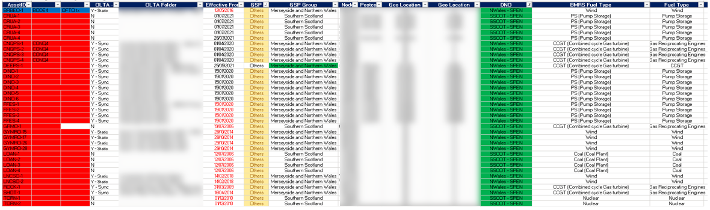

Figure 6: Enhanced data extract

As can be seen from the above enhanced data extract, NGESO has been able to add information relating to whether units are static or synchronous, whether they are believed to be transmission connected and also a unit name in some cases which it was hoped would be helpful to DNO in identifying the units. Some postcode and geospatial data had been enhanced also, notwithstanding the early point around some of the postcode data relating to locations other than the actual generating units.

Both datasets were shared with SP Energy Networks for them to use in the next stage of the process ‘BMU mapping’.

* 1. BMU Mapping (SP ENERGY NETWORKS)

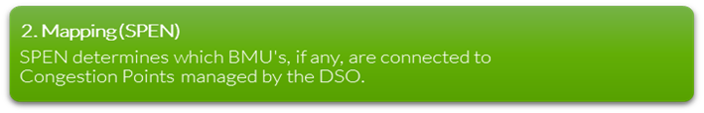

* + 1. Data transfer and format

Initially the BMU data (v1.0) was sent via email and contained 196 entries in excel format.

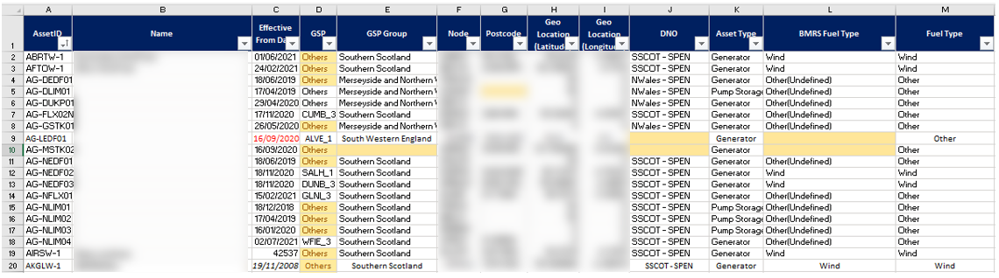

Figure 7: Indicative screenshot of part of the original (v1.0) BMU data transfer

Subsequently, a reduced version (v2.0) was shared containing just 15 of the original 196 entries. This followed NGESO having cleansed their original data, including the removal of the following entries:

* BMU participants that were inactive; and
* BMU participants connected to the transmission network, which is outside of scope for this primacy use case.

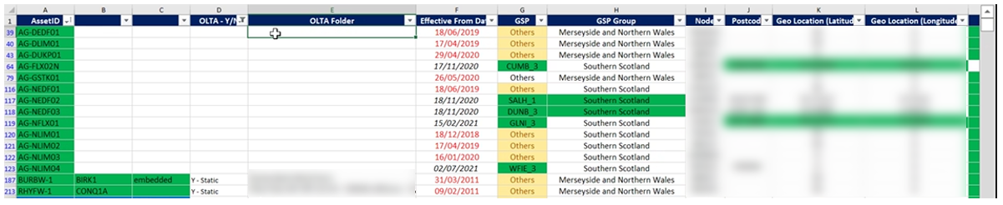

Figure 8: Indicative screenshot of part of the second (v2.0) BMU data transfer

The reduced volume of entries contained in v2.0 made the process of mapping and analysing the BMU data less onerous for the DNO.

* + 1. Geospatial data attributes

The following geospatial attributes were included in the BMU dataset:

* Latitude & Longitude
  + Unfortunately, their accuracy was questionable[5].
  + We therefore could not rely on lat-long coordinates for mapping them.
* Post code
  + Given that so few entries had post codes we could not rely on that attribute for mapping them.[6]
* Node
  + Whilst they didn’t match exactly, the names of these nodes often bore some semblance to the names of SP Energy Networks Grid Supply Point (GSP), which lead us to infer that, in those cases, the BMU was connected, albeit at a lower voltage, to the corresponding GSP.
  + NB: the location inferred from the node value was sometimes not corroborated by that obtained from the lat-ong coordinates. Given the observations that had already led us to question the accuracy of lat-long coordinates, it was decided that, in any instance of discordance, the Node value should take precedence.
* Asset ID
  + Sometimes the ‘asset ID’ (see columns A-C in table above) includes a reference to a place name

Of the four geospatial attributes provided in the BMU data, the ‘node’ attribute was the most consistently populated. It was also evaluated to be the most accurate, with the lat-long data in particular showing evidence of pervasive errors.

Consequently, a decision was made to principally rely upon ‘node’ data in the mapping process, but with regard also to the other spatial attributes wherever they suggest a match to a recognised DNO congestion point. Further detail is provided below in Section 5.2.4.

* + 1. DNO congestion point data

Full details of the congestion points that SP Energy Networks manage through flexibility, including their name, location and periods during which they’re managed, are all publicly available via the links provided below in ***Table 3****.*

|  |  |
| --- | --- |
| Congestion Point Data (SP Energy Networks) | |
| BaU | [Project FUSION website](https://www.spenergynetworks.co.uk/pages/fusion.aspx#tablist1-tab7) |
| Project FUSION | [SP ENERGY NETWORKS Flexible Power website](https://www.flexiblepower.co.uk/locations/sp-energy-networks)  <https://www.flexiblepower.co.uk/downloads/1131> |

Table 3: Publicly available SPEN Congestion Point data

* + 1. Mapping BMUs to DNO Congestion Points

A given BMU represents a potential conflict to the DNO when *both* of the following criteria are satisfied:

1. Location: The BMU is connected to a congestion point (CP) being managed by a flexibility contract; and
2. Timing: The specific time period being considered overlaps with the active window of the associated flexibility contract.

Therefore, when analysing the BMU data for potential conflicts, the DNO needs to consider the following questions:

1. Timing: Do any DNO CPs have flexibility contracted to be available during the reporting week in question?
2. Location: If so, do any of those DNO CPs have BMUs connected to them?

This section describes the processes implemented by SP Energy Networks to explore these questions and identify potential conflicts between the BMU data received from NGESO (see section 5.2.1) and SP Energy Networks’ own CP data.

**Step 1**: Filter CPs by timing of flexibility contract

Columns V & W of the ‘procurement’ tab in the publicly available <https://www.flexiblepower.co.uk/downloads/1131> show the start and end dates of the flexibility contracts in place on the DNO network.

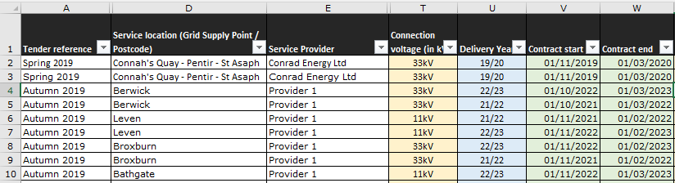

Figure 10: Start and end dates for the flexibility contracts associated with each congestion point

Filters were applied to columns V & W of the CP data to limit our attention exclusively to those with flexibility service agreements in place which cover the period being investigated.

When conducting the trial in December, the following filters were applied to the CP data:

1. Column W: remove all rows with contracts *ending* prior to December 2022
2. Column V: remove all rows with contracts *starting* after Dec 2022

That reduced the number of congestion points being considered from over 8000 to just 8.

**Step 2**: Locate CPs having potential BMU’s connected

As mentioned already in Section 5.2.2, the similarity in names often allowed the ‘Nodes’ in the BMU data to be associated with the ‘GSPs’ in the CP data.

Also, the asset ID in the BMU data sometimes contains references to place names, which can be (albeit with less confidence) associated with GSP’s names that represent places that are geographically nearby.

In this step, the following data was compared in order to establish potential location matches:

1. The GSP names for those 8 entries in the filtered SP Energy Networks CP data (column ‘D’)

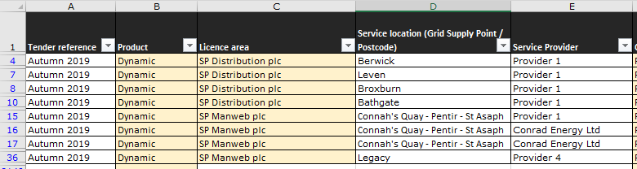

Figure 11: GSP names (SPEN Congestion Point data)

1. The Node names (Column ‘I’) and Asset ID’s (Columns ‘A-C’) for those 15 entries in the NGESO BMU data (V2.0).

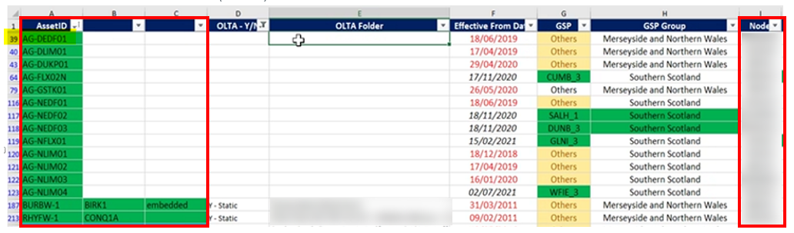

Figure 12: Node names and AssetID (NGESO BMU Data)

The findings of that comparison are presented below showing the 2 x BMU entries which were identified as potential conflicts (highlighting added to indicate the apparent similarities observed):

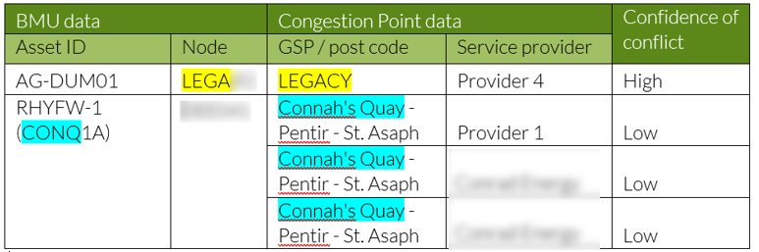

Table 4: Association of BMU entries with Congestion Point GSP’s

This process was repeated on a weekly basis, each time adjusting the filter in column V of the CP dataset to consider only those CPs that had active flexibility contracts in place during the week in question.

**Step 3**: Duration of the risk of conflict

Once BMUs have been identified that constitute a potential RoC for a given week, the specific hours of the week during which the potential conflict persists had to be ascertained. This required reference to the flexibility contracts in place at the associated CPs; the aim being to identify their associated ‘service windows’ during the week in question.

This information is available in columns Y & Z of the publicly available <https://www.flexiblepower.co.uk/downloads/1131>

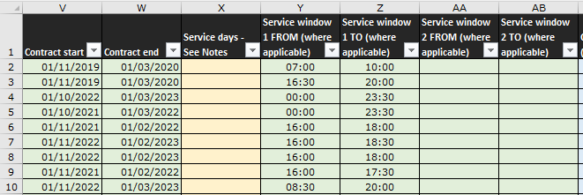

Figure 13: Service windows of shortlisted Congestion Point contracts

The start- and end-time of a given CP service window represent the start- and end-time of any associated risk of conflict identified at that CP.

**Step 4**: Direction of the risk of conflict

In order to ascertain the ‘direction’ of the risk, reference had to be made to the type of flexibility service being provided at the congestion point. This information is available in columns F & P of the publicly available <https://www.flexiblepower.co.uk/downloads/1131>

In representative screenshot below, the flexibility services being provided to the CPs in view are all selected are all for ‘Generation turn-up / Demand turn-down’.

In light of this information, we can deduce that a conflict with a connected BMU would only exists if the BMU were to provide a (contrary) ‘Generation turn-down / Demand turn-up’ service.

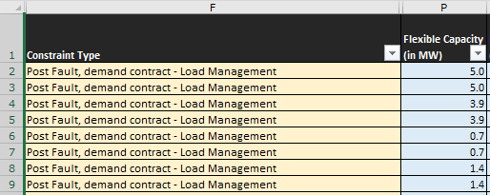

Figure 14: Constraint type showing the ‘direction’ of the constraint

**Step 5**: Validation of the risk of conflict

Currently, within SP Energy Network’s BaU flexibility market, flexibility service providers (FSP’s) providing Secure and/or Dynamic products are required to submit (by midnight each Wednesday) a declaration to the DNO of their flexibility availability, at each CP, for the week ahead. The DNO then has until 12:00 noon the following day (Thursday) to either accept or reject that offer of availability. In other words, each Thursday, upon having analysed the week-ahead forecast loading of its networks, the DNO can relieve FSPs from having to maintain availability, at any given CP, for the next 6 days.

Prior to the DNO submitting the RoC report to the ESO each Tuesday, it would be prudent of the DNO to first check the continued validity of the conflict for the week ahead by confirming that none of the associated FSPs had their declarations rejected by the DNO on the previous Thursday.

Unfortunately, the benefit of including this step in the process was not identified until after the completion of the trial and so it was not included. Effectively that means that the RoC reporting process employed the conservative assumption that the DNOs forecasts always indicated the need for flexibility and that the DNO always accepted every FSP availability declaration for the week ahead.

* + 2. Scope for improvement

SP Energy Networks provided the following feedback on what could be improved to facilitate the BMU mapping process.

* + - 1. BMU geospatial data

Mapping would be easier if the geospatial data provided in the BMU data transfer to SP Energy Networks were improved. Suggestions for consideration include the following:

* Provide more geospatial data attributes (e.g., Meter Point Administration Number (MPAN) data).
* Improve data accuracy of latitude and longitude coordinates.
* Indicate where BMU entries corresponds to assets listed in SP Energy Networks’ [embedded capacity register](https://www.spenergynetworks.co.uk/pages/embedded_capacity_register.aspx)

Feedback from SP Energy Networks control room suggested that it would be useful if future iterations of the BMU data transfer were to include the following:

* The name of the primary substation that the BMU is connected to (where applicable) along with the circuit reference.
* The Meter Serial Identification (MSID), which would allow protection to be easily applied during Electricity Supply Emergency Code (ESEC) events.
* Both installed capacity and forecast output.
  + - 1. Mapping process

The method used during the trial for mapping BMU data was very reliant on manual matching of BMU and SP Energy Networks’ assets as through using the names of substations, either by their lexical[7] similarity or by the known geographical proximity of the distinct placenames that they respectively reference[8]. This process would be complex to automate and scale. If, however, the BMU data transfer were to contain accurate coordinate data and or MPAN data, automating the mapping those geospatial attributes to the DNO network might be much less complex and thus easier to scale.

* + - 1. Risk validation

Given that Step 5 was not trialled, it would be prudent to test the process for validating RoCs and assess the impact that would have on the frequency of ‘conflicts’ each week within the RoC report.

* 1. Risk of Conflict Reporting (SP ENERGY NETWORKS)

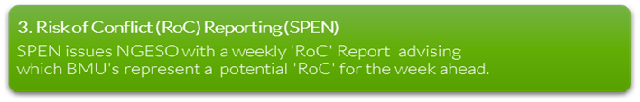

The RoC report was successfully issued to the NGESO each Tuesday for four consecutive weeks commencing October 19th, 2022.

Those RoC reports contained several instances of conflicts having been identified, and their successful communication to NGESO demonstrates the efficacy of process contained within the BM1a rule.

* + 1. Communication protocol

Each week the DNO emailed a completed RoC report to the NGESO, communicating the perceived risk of conflict for the week ahead associated with each of the BMU data entries provided by NGESO.

In order to standardise the RoC reporting process, the ENA specified the protocol for implementing that weekly communication, full details of which are provided in *Appendix 3 – Roc Reporting Protocol.*

A summary of the weekly RoC reporting process is provided below.

* Communication Mode: Email containing RoC attachment
* Frequency: Weekly
* Timing: By 5PM each Tuesday
* Origin: mgreen@spenergynetworks.co.uk
* Destination: tranreq@nationalgrideso.com
* RoC File Type: .csv
* RoC Format & Content: See Section 5.3.2
* RoC Reporting Period: The coming Saturday to Friday, inclusive.
* RoC file name: SP ENERGY NETWORKS-BM-CONFLICT-<start

date,ddmmyyyy>-<end date,ddmmyyyy>.csv

* + 1. RoC reporting format

The RoC report was sent weekly, as an email attachment, to NGESO (see Section 5.3.1 for details).

For consistency of approach, the ENA produced a template RoC Report for the purposes of this trial, a copy of which is provided for reference in *Appendix 4 – Roc Reporting Template.*

For illustration of how this template was applied in the trial, a screenshot is provided below showing the completed RoC report that was issued to NGESO on Dec 13th.

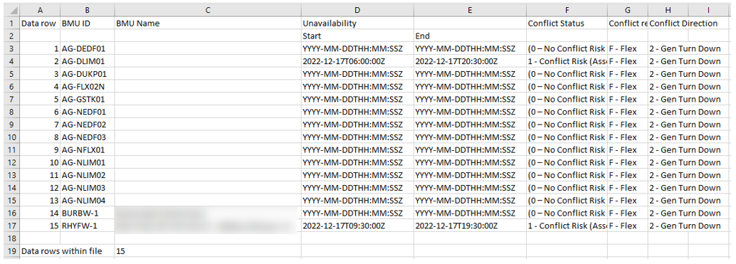

*Figure 15: RoC report, Dec 13th2022.*

***Table 5*** below summarises the fields contained within the RoC reporting template and how they were populated during the trial.

|  |  |  |
| --- | --- | --- |
| RoC Field | Source data for populating | Section Ref |
| BMU ID | * NGESO BMU Data. | Section 5.2.1 |
| BMU Name |
| Unavailability Start Date and Time. | * Columns **Y** & **Z** of the <https://www.flexiblepower.co.uk/downloads/1131> | Section 5.2.4,  Step 4. |
| Unavailability End Date and Time |
| Conflict (availability) Status   * 0 – No Conflict Risk (Asset Available), * 1 – Conflict Risk (Asset Unavailable), | * Columns **A, C** & **I** of the NGESO BMU Data. * Column **D** of the <https://www.flexiblepower.co.uk/downloads/1131> | Section 5.2.4,  Step 3. |
| Conflict Reasons   * A – ANM, * F – Flex, * O - DNO Outage | * Given the scope of this trial, we were only concerned with those conflicts arising from ‘Flex’ activities. | N/A |
| Conflict Direction   * 1 – Generation turn-up / Demand turn-down, * 2 – Generation turn-down / Demand turn-up, * 3 – Demand turn-up and turn-down) | * Columns **F** & **P** of the <https://www.flexiblepower.co.uk/downloads/1131> | Section 5.2.4,  Step 5. |

Table 5: RoC report fields and how to populate each

* + 1. Scope for improvement

1. Roc Reporting template
2. This trial revealed that, without guidance there is potential for confusion when populating the RoC reporting template. One interpretation of the RoC report format limits users to populating a single line item (max) per BMU. This would prevent DNOs from being able to record conflicts that occur for only part of each day (e.g. instead of being able to report conflicts between 09:00-10:00 each morning, it would be interpreted as a single conflict extending from 09:00 on day-1 through until 10:00 on day-6).

This incorrect interpretation could result in excessive conflict durations being reported, which would be detrimental to the BM and its participants. This report therefore recommends that, in order to prevent the impact of this mistake being made again (at scale), training or guidance should be provided to DNO users of the RoC report.

1. The cells in column F allow for two drop down options, one of which is as follows:
2. – No Conflict Risk (Asset Available – record not included in the file)

The inclusion of the text ‘record not included in the file’ in the above drop-down menu option creates ambiguity as to whether instances of No conflict should be recorded within the report, or not. This report suggests that, in order to ensure consistency of approach, the drop-down menu options be edited to avoid this ambiguity.

1. If ‘No conflict’ BMU’s are to be included in the RoC report then we suggest introducing the dropdown option ‘N/A’ in columns G & H.
2. RoC Guidance
   1. The attached guidance specifies the following file name convention: SP ENERGY NETWORKS-BM-CONFLICT-<start date, ddmmyyyy>-<end date, ddmmyyyy>.csv

However, the <> characters are not permitted characters in the file name, and so this report recommends that the specified naming convention be adjusted accordingly.

* 1. During the trial, the following step in the guidance was not observed:

*“On receipt of the Risk of Conflict report the ESO will return an email handshake back to SP Energy Networks to confirm receipt – this email will originate from the following email address: tranreq@nationalgrideso.com and will be sent to:* [*mgreen@spenergynetworks.co.uk*](mailto:mgreen@spenergynetworks.co.uk) *and will be issued by 9am each Wednesday morning following receipt of the report on the Tuesday at 5pm.”*

This step could conceivably be automated by specifying that, when the DNO issues the RoC report each week, they activate ‘read reports’ in the sending email. But this report recommends that the DNO needs not only to know that NGESO has received the ROC report but, crucially, what they have done about it. I.e., which BMU assets have been ‘frozen’ for the following week as a result?

1. Communication process

In the future, we should look to incorporate data exchange into the scheduling and dispatch tools, albeit that they presently still need to be developed.

* 1. Downstream ESO process (NGESO)

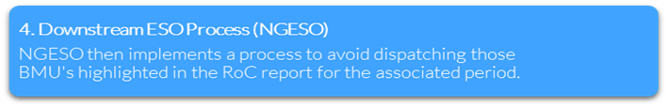

*Appendix 3 – ESO Downstream Process* provides a high-level illustration of the downstream ESO process followed in the trial.

From the outset, ESO was keen to try and utilise existing processes within the Planning and Control Room teams to allow quick, effective and successful outcomes to be achieved in the implementation of any Primacy rules. Good collaborative working across the various ESO teams allowed them to define a process that builds on the existing framework and therefore should be able to be implemented with minimum of change across the various ESO teams.

The successful receipt of the RoC report from SP Energy Networks has been proven and tested to ensure correct report format and successful report transfer into ESO (via email). Positive confirmation of receipt was provided occasionally to SP Energy Networks (also via email). In the future this will be automated to provide consistent positive confirmation of receipt, as per the recommendation provided in Section 5.3.3, part ‘b’.

Once received the report was then passed through the normal ESO planning process as illustrated in *Appendix 3 – ESO Downstream Process* to ensure that any BM Units showing a risk of conflict as detailed in the RoC are removed from the ESO BM Control Room desks options as units available to be used to implement corrective actions in the event of a system imbalance. This proves the ESO internal process, and that any BMUs identified as having a potential risk of conflict, are removed from the ESO ENCC mitigation options via the daily document handed between Planning and Control Room teams (this document is referred to as a daily Picasso document).

On receipt of the weekly RoC report, the ESO planning teams are able to manually interpret the data, understand the impacts and subsequently ensure that these impacts are built into the daily handover via the Picasso (ESO process used to document anticipated constraints and impacts). However, the ESO team concluded that, although this manual process is manageable potentially for a single DNO it is not scalable or sustainable for multiple DNOs passing RoC data in to ESO, nor would it support the Primacy Rule 1b of ESO receiving more frequent RoC reports than weekly. As a result, the ESO is currently developing a tool that will be able to receive multiple RoC reports (all in the same format) from multiple DNO sources and consolidate into a single internal view that ESO planning and control teams will have access to – this to be termed the Daily Unavailability Report within ESO. This consolidation tool is currently under development and is anticipated for delivery sometime before the end of March 2023, allowing a potential wider rollout of the BMU Primacy process across multiple DNOs as well as a potential to consider more frequent DNO RoC reporting as aspired to in Rule 1b.

The format of the incoming RoC report to ESO from DNOs has been defined, tested and issued as part of this trial process. As the participating parties are expanded wider, all DNOs will be expected to use the same format for their RoC report so that the ESO consolidation tool can combine into the consolidated Daily Unavailability Report as detailed earlier. This will give a consistent and scalable process for DNOs to submit regular RoC reports which will then be fed into the defined ESO process as captured and detailed earlier in this section.

* + 1. Scope for improvement

Following the successful submission of RoC reports to the NGESO, confirmation of receipt was never returned to SP Energy Networks. This report recommends that a process should be agreed for communicating, not only receipt of the RoC, but also the specific actions that the NGESO plans to implement (or has implemented) in response to the said RoC.

# Analysis

The following section provides a concise summary of some of key characteristics of the trial. It should be noted that the feedback provided is reflective of the trial only and, should the solution be scaled for BaU, it is likely that these figures would change significantly as a result of any of the following variables being adjusted: input data (volume, quality, resolution, accuracy etc), increased departmental involvement (e.g., DNO control room involvement), level of automation required and approximation toward real-time data exchange.

|  |  |  |  |  |
| --- | --- | --- | --- | --- |
| Process Stage | Man-hours | Repetition frequency | Accuracy / reliability  (1 = poor, 5 = perfect) | Scalability / Potential for automation  (1 = poor, 5 = perfect) |
| 1. BMU Data Transfer (NGESO) | 30 | Once | 1  The disparate nature and varied accuracy of this data was clearly the biggest challenge encountered so far in the process implementation, leading to much effort to try and resolve. | 4  An up-front data cleanse exercise or better still, definition of a process that utilises industry available data (such as that held by Elexon or a similar body) is recommended to ensure a consistent and robust method of DNO BMU participant identification and management of new incoming or exiting BM parties. |
| 1. Mapping (SP ENERGY NETWORKS) | 7.5 | Weekly | 3  (The accuracy of the matches identified during the trial has not been verified. The approach taken to identify potential conflicts was conservative, with even tenuous associations being considered potential conflicts. We’re therefore confident that most real conflicts are likely to have been captured but acknowledge that some of the potential conflicts identified might have been invalid.) | 1 - 4  (This step could conceivably be almost entirely automated, provided reliable, high-resolution geospatial attributes were included in the BMU data transfer [ See Section 5.2.5 for more detail]. However, that is currently not the case and so significant manual intervention is required until the data can be improved.) |
| 1. Risk of Conflict (RoC) Reporting (SP ENERGY NETWORKS) | 4 | Weekly | 4  (There is scope within the RoC format for ambiguity and this could lead to error arising from inconsistent human interpretation. See Section 5.2.5 for more detail). | 4  (Because the RoC report contains, by default, all BMU entries, the DNO only has to edit those entries for which the previous ‘mapping’ step identifies a risk of conflict. Using a hosted shared .csv document could avoid the need for email exchanges. |
| 1. Downstream ESO Process (NGESO) | 3 | Weekly | N/A | The DNO could activate ‘read receipt’ on the emails used to submit the RoC report. That would provide an automated confirmation of receipt. However, this report recommends that the ESO also implement some of automated messaging service that confirms tot the DNO what action will be /has been taken in response to their receipt of the most recent RoC report. |

Table 6: Analysis of each stage of the process against specific themes

# BaU Implementation: Considerations for DNO

2. * 1. Objective

This trial has successfully demonstrated the manual implementation of ‘primacy rule 1a’ to resolve service conflicts between ESO-procured and DNO-procured flexibility across the SP Distribution Network.

Beyond this trial, and subject to the evolving strategy of WS1a Product 5[9] and the updated Technical Working Group for 2023 - the objectives of which we seek to continually align ourselves with – DNOs are committed to embedding a manual implementation of this primacy rule into BaU where appropriate, and to iteratively enhance those processes thereafter in an attempt to increase automation and approximate real-time data exchange. The form which that BaU implementation ultimately takes within each DNO may differ to the approach demonstrated in this trial, and it is beyond the scope of this report to prescribe that form. However, with the end-goal of optimised BaU implementation in mind, this section seeks to highlight some of the challenges (and opportunities) that are anticipated in full scale deployment.

* + 1. Resourcing

Section 6 above quantifies the human resource required by the DNO (and ESO) for this one-off trial implementation of the primacy rule. It reports that the human resource required from DNO for implementing the trial was approximately **11.5 person-hours/week.** It should be noted that this trial was not intended to be representative of the scale of endeavour associated with BaU deployment, which would likely require significantly more human resource.If this approach were to be embedded into BaU, the DNO would need to consider:

* How that human resource requirement might significantly **expand** (perhaps as a result of anticipated growth in the volume of conflicts being managed in this use case or the measures being taken to achieve near real-time communications and the various touch points within the business that would need to be involved).
* Which departments that human resource would originate from within the business (what its **structure &** **composition** would be).
* Which department would take ultimate **ownership** of this enduring BaU activity.

Table 7 below provides a suggested framework for considering which parts of the business might be affected if this approach were to be embedded into BaU.

It considers each stage of the implementation in turn and prompts the user to ask some fundamental questions about which parts of the business might need to be involved at each stage. The aim of providing this table in this report is not to recommend the resourcing structure for a BaU Implementation model. Rather it is intended as a tool to facilitate the consideration of some fundamental questions that would hopefully inform the conception of such a model.

|  |  |  |  |  |
| --- | --- | --- | --- | --- |
| Stage in the process | Who?  (Which departments might be affected?) | How?  (How might they be affected?) | Why? | When? |
| Mapping | e.g. GIS team | They might be able to assist with mapping the BMU data to DSO congestion points | This specialist skill set could expediate the mapping process, especially if the ESO were able to provide BMU data comprising reliable, high-resolution geospatial data. | One-off exercise upon receipt of the BMU data.  (Infrequent refreshes upon receipt of each update from ESO. Perhaps annually?) |
| Other | - | - | - |
| RoC Reporting | e.g., the Control Room (or  the department ultimately responsible for decision-making in DSO flexibility dispatches). | It might be prudent to provide the Control Room with visibility of known conflicts (even week ahead). | This would help them to understand the risks associated with their network and would allow them to make informed decisions when they come to schedule and dispatch flexibility | Week-ahead visibility of conflicts would be helpful.  As the DSO flexibility market approximates real-time trading, we should aspire to provide the control room with real-time visibility of primacy rule conflicts. |
| Other | - | - | - |

Table 7: Framework for considering resourcing implications

* + 1. Processes & Data

Key to accurately quantifying the DNO resourcing requirements will be to first establish a clear understanding of the process that the BaU approach will comprise and, crucially, the quality of data input that it can anticipate from the ESO.

This report recommends that, prior to any BaU implementation process being executed, discussions should be held with ESO to formulate an accurate timeline for any enhancements to be made to the BMU data that will be made available to the DNO.

* + 1. Risk Management

This report recommends that, when considering the BaU, implementation of any primacy rule activity, due regard should be paid to the following two hazards and their associated unintended consequences:

* + - 1. Insufficient intervention

By this we refer to the following scenario:

* The DNO fails to identify and report all real conflicts
* Those BMU assets are called-upon by the ESO and give rise to a real conflict
* This reduces the efficacy of any flexibility dispatched by the DNO to manage its network during that conflict
* Whilst its felt impact would, at least in the short term, not be any worse than the status quo - as no primacy rules are currently implemented and so any existing conflicts are presumably occurring unnoticed - this could have an adverse impact (particularly on the D-Network), the severity and impact of which could increase commensurately with the growth in reliance on DSO flexibility and the associated increase in conflicts.
  + - 1. Excessive intervention

By this we refer to the following scenario:

* The DNO takes a conservative approach* to identifying risks of conflict and consequently submits RoC reports to the ESO which report an excessive risk of conflict that actually exists. (*This might, for example, be a result of BMU geospatial data only being available in very low-resolution or simply in an effort to avoid the hazard described in section 7.1.4.1).
* The ESO then ‘freezes’ those BMU’s reported as constituting a risk of conflict and a limit is imposed to their potential for participation in the BM for the week ahead.
* This ‘freezing’ of the BMU has an impact on their revenue from the BM for that week.
* This hazard could have the unintended effect of causing unnecessary loss of earnings to BM participants and reducing competition within the BM market, indirectly pushing prices up for customers.

# 

# Conclusion

This section contains a summary of the extent to which the trial was successful in demonstrating the implementation of the primacy rules being trialled and in delivering upon the learning objectives outlined in *4.4.2 Learning objectives*. Crucially it also reflects upon the challenges encountered and distils the opportunities identified for improvements that could facilitate the adoption of these primacy rules into BaU.

|  |  |  |  |
| --- | --- | --- | --- |
| Process Stage | Successes | Challenges | Recommendations |
| BMU data transfer | * Good collaboration between ESO and SP Energy Networks to refine and improve the data transfer format. | * The BMU data transfer lacked reliable, hi-resolution geospatial data; data fields were specified early on in the trial and ESO attempted to extract this data from their systems but with limited success. * ESO source data was disparate and inconsistent. | * ESO to continue and conclude the ongoing data capture & cleansing exercise to resolve the issues with source data. * Consider utilising alternative source(s) for BMU data (i.e., NGESO and Elexon) to give a single version of the truth (initial discussions already taken place with Elexon). |
| BMU data mapping | * The trial was able to map BMU data to SP Energy Networks congestion points and, for the first time, identify ‘risks of conflict’ which would otherwise have gone unnoticed. | * Lack of reliable, high-resolution geospatial data made the process for mapping BMU data to DNO congestion both:   + highly dependent on human input (to identify similarities with names), and therefore   + complex to automate & scale. | * Consider how to improve BMU data   + Data availability (populate empty geospatial data fields)   + Data accuracy (improve reliability of coordinates and post code data).   + Include MPAN data.   + Indicate where BMU entries correspond to specific assets listed in SP Energy Networks’ [embedded capacity register](https://www.spenergynetworks.co.uk/pages/embedded_capacity_register.aspx)   + Appropriate geospatial markers (consider how to represent the areas covered by those BMU’s which comprise multiple assets at different location * Consider the use of algorithms to help automate the matching of BMUs to CPs using whatever reliable data is available in the BMU data transfer. |
| RoC reporting | * The RoC report was successfully issued to the NGESO each Tuesday for four consecutive weeks starting Oct 19th 2022. * Those RoC reports contained several instances of potential conflicts having been identified by the DNO. * Their successful identification and communication to NGESO demonstrates the efficacy of the BM1a rule to help manage this use case. | * There is some ambiguity within the RoC reporting template (particularly the dropdown response options) which could lead to error arising from inconsistent human interpretation. * The reliance on an individual emailing the weekly RoC, report to the ESO, provides an opportunity for improvements to be made through automation. | * Minor adjustments to the RoC reporting template, particularly the drop-down options, would avoid the ambiguities. that currently exist therein. See Section 5.3.3 for more detail. * As an alternative to sending emails, there would be benefit of using a shared live document which could be updated weekly, and automated. |
| Downstream ESO process | * Process defined that will predominantly fit with existing ESO Planning and Control Room processes. * Requirements for an improved solution in ESO understood, captured and being developed – supporting wider rollout and Rule 1b. | * Manual process to interpret and understand incoming RoC reports is not scalable beyond a single DNO. * SP Energy Networks received no confirmation from NGESO that the RoC and been received or any meaningful information about how it would be used. | * A process should be agreed for the ESO to positively communicate, not only receipt of the RoC, but also confirm that those BMU’s identified as constituting a risk have been removed from the ESO BM Control Room desk’s options as units available to be used to implement corrective actions in the event of a system imbalance. |



1. Glossary

|  |  |
| --- | --- |
| Term | Definition |
| Balancing Market Unit (BMU) | A service provider that contracts, monitors, aggregates, dispatches and remunerates flexible assets at the customer side. (USEF terminology) |
| Congestion Point (CP) | Payments made for being available to deliver the contracted Flexibility Service during a specified time period (described as the ‘Service Window’). |
| Risk of Conflict (RoC) report | The use of a heat engine or power station to generate electricity and useful heat at the same time. |
| Distribution System Operator (DNO) | As defined in DIRECTIVE 2009/72/EC: A natural or legal entity responsible for operating, ensuring the maintenance of and, if necessary, developing the distribution system in a given area and, where applicable, its interconnections with other systems and for ensuring the long-term ability of the system to meet reasonable demands for the distribution of electricity. |
| Energy System Operator (ESO) | The Electricity System Operator (ESO) performs several important functions; from second-by-second balancing of electricity supply and demand, to developing markets and advising on network investments. The ESO has an important role to play in the UK’s transition to a decarbonised, decentralised and digitalised energy system. |
| Flexibility | Ability of an asset or a site to purposely deviate from a planned or normal generation or consumption pattern. |

1. Appendix 1 – USEF Overview

The USEF framework aims to facilitate effective coordination across all the different actors involved in the electricity market by providing a common standardised roles model and market design while describing communication requirements and interactions between market roles. USEF turns flexible energy use into a tradeable commodity available for all energy market participants, separated from (but in coordination with) the traditional electricity supply chain, to optimise the use of resources. USEF focuses on explicit demand-side flexibility, in which prosumers are contracted by the aggregator to provide specific flexibility services using Active Demand and Supply (ADS) assets. USEF acknowledges but does not provide detailed considerations for implicit demand-side flexibility or peer-to-peer energy trading.

To facilitate the transition towards a cost-effective and scalable model, the framework provides the essential tools and mechanisms which redefine existing energy market roles, add new roles and specify interactions and communications between them. In addition, the USEF standard ensures that all technologies and projects will be compatible and connectable to the energy system, facilitating project interconnection, hence fostering innovation and accelerating the smart energy transition. By delivering a common standard to build on, USEF connects people, technologies, projects and energy markets in a cost-effective manner. Its market-based mechanism defines the rules required to optimise the whole system, ensuring that energy is produced, delivered and managed at lowest cost for the whole system and effectively for the end-user. The USEF framework provides:

* a standardised common framework designed to be implemented on top of current energy markets such as wholesale, retail and capacity markets.
* A description of the flexibility value chain (FVC) involving new and existing market players and giving a central role to the aggregator in facilitating flexibility transactions.
* A roles model and interaction model to enable the implementation of different business models and interactions between actors
* A market design described by the Market Coordination Mechanism (MCM) which sets out the phases and interaction requirements for flexibility transactions. The MCM provides all stakeholders with equal access to a smart energy system. To this end, it facilitates the delivery of value propositions (i.e. marketable services) to various market parties without imposing limitations on the diversity and customisation of those propositions.
* Detailed communication and markets access requirements taking into considerations privacy and cybersecurity issues.

The USEF framework was initially developed by the USEF Foundation. In 2014, the USEF Foundation was inaugurated to accelerate the establishment of an integrated smart energy market which benefited all stakeholders, from energy companies to consumers. USEF was an early mover, a combined force of parties and professionals with a shared goal. Together they explored new territories to help unlock and structure the future market and, as a result, many elements of USEF can now be found in standardisation and harmonisation policies at both national and European level.

In 2021, 7 years later, the work of the USEF Foundation was therefore considered complete and USEF Foundation had ceased to exist by 1 July. To safeguard the legacy of the USEF foundation, the USEF framework, including the UFTP protocol (recently rebranded to Shapeshifter) is being maintained by the GOPACS organisation. The [SHAPESHIFTER](https://www.lfenergy.org/projects/shapeshifter/) protocol has also been adopted by the Linux Energy Foundation, offering a platform for the maintenance and support of the protocol.

1. Appendix 2 – Balancing mechanism flow diagrams

High-level process diagrams to illustrate how the ESO manages voltage fluctuations, system inertia and import constraints.

Voltage Management

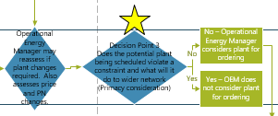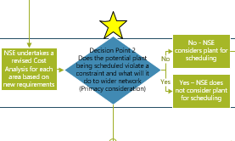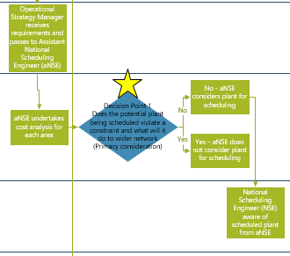The ESO needs to ensure that the various voltage levels across the transmission network are maintained within the limits set out within the Security and Quality of Supply Standards (SQSS). In order to achieve this, the diagrams below show some of the process elements and decision-making points that are considered:

Figure 16: *High level voltage management process*

 System Inertia Management

The ESO needs to ensure that the overall level of inertia on the system at any one point in time is sufficient to manage the forecast Rate of Change of Frequency (ROCOF) for credible events. In order to achieve this, the following process diagrams show some of the process elements and decision making points that are considered:

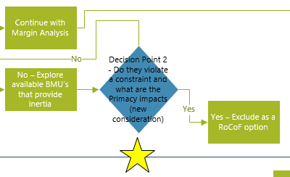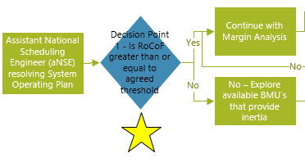

*High level system inertia management process*

Figure 17: High level system inertia management process

Constraint Management

As with the TCM example, the ESO needs to ensure that each defined constraint limit across the transmission network is managed in accordance with asset ratings. In order to achieve this, the following diagram shows some of the process elements and decision making points that are considered:

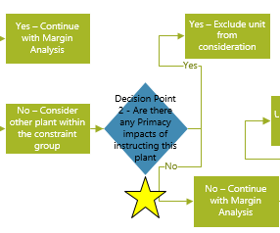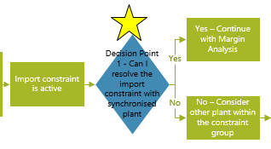

Figure 18: High level process for constraint management in the BM

1. 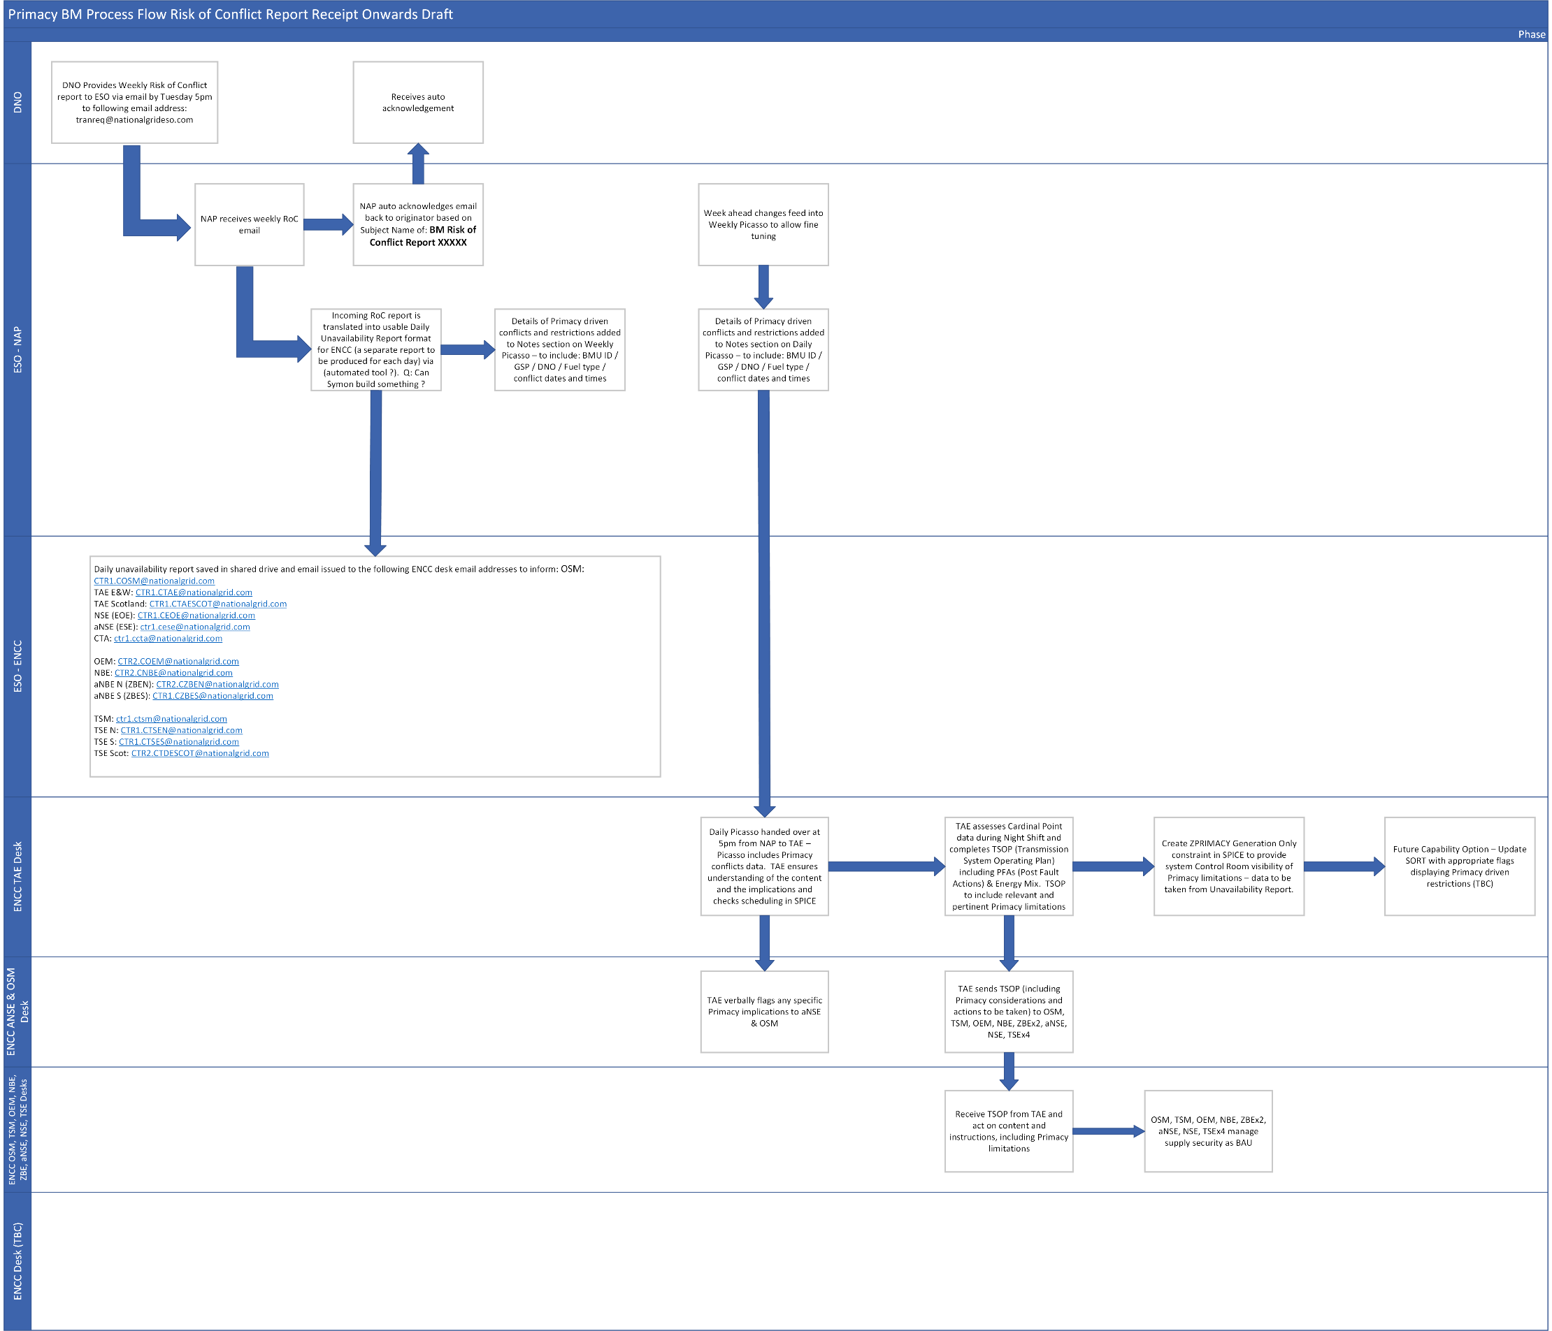Appendix 3 – ESO Downstream Process
2. Appendix 4 – Roc Reporting Protocol

1a. BM Forecast Risk of conflict

Common approach across DNOs

1. Each week the DNO will send an email with the Risk of Conflict report to: tranreq@nationalgrideso.com with the following week’s data showing BMU sites carrying a risk of conflict due to planned / forecast upcoming activity within the DNO network.
2. The email from the DNO is expected to be delivered by Tuesday 5PM with the potentially conflicting units details starting from the following Saturday (to fit in line with Planning cycles of Saturday – Friday).
3. The DNO will send the emails only once per week
4. File name:

SP ENERGY NETWORKS-BM-CONFLICT-<start date, ddmmyyyy>-<end date, ddmmyyyy>.csv

1. This file will contain the following fields:

* BMU ID
* BMU Name
* Unavailability Start Date and Time. All dates and times should be in the format as follows – [YYYY-MM-DDTHH:MM:SSZ]
* Unavailability End Date and Time All dates and times should be in the format as follows – [YYYY-MM-DDTHH:MM:SSZ]
* Conflict (availability) Status (0 – No Conflict Risk (Asset Available – record not included in the file), 1 – Conflict Risk (Asset Unavailable),
* Conflict Reasons (A – ANM, F – Flex, O - DNO Outage)
* Conflict Direction (1 – Generation turn up / Demand turn down, 2 – Generation turn down / Demand turn up, 3 – Demand turn up and turn down)

1. To ensure the recipient can validate that the file is complete, the file will also include a footer row stating the total count of data rows within the file.
2. Conflict Risk periods will be included as a single entry covering overall time of conflict and will be rounded to the nearest 30 mins time granularity prior to and following the conflict risk (these being on the hour and half hour). So if a unit were to be unavailable from 08:42 until 11:49 then the unavailability times would be shown as 08:30:00 until 12:00:00
3. The ordering of the data within the file is to be in line with that shown above.
4. SP ENERGY NETWORKS email address from where the week-ahead risk of conflict files will be sent is: [mgreen@SP Energy Networksergynetworks.co.uk](mailto:mgreen@spenergynetworks.co.uk)
5. Subject line for the weekly email from the DNO to NGESO is: BM Risk of Conflict Report DD/MM/YY
6. On receipt of the Risk of Conflict report the ESO will return an email handshake back to SP ENERGY NETWORKS to confirm receipt – this email will originate from the following email address: tranreq@nationalgrideso.com and will be sent to: [mgreen@SP Energy Networksergynetworks.co.uk](mailto:mgreen@spenergynetworks.co.uk) and will be issued by 9am each Wednesday morning following receipt of the report on the Tuesday at 5pm.
7. Appendix 5 – Roc Reporting Template



1. ENA, Primacy Draft Rules Increment 1, Version 2 (April 2022)
2. Ibid
3. Ibid
4. These are intended for illustrative purposes only and do not reflect a detailed delivery model for ESO RDPs, since they present a high-level approach to achieve mitigation of conflicts and coordinated dispatch of ESO and DNO services. It should be noted that there could also be other approaches/variables, not presented as part of this report, that could offer similar or more efficient solutions, which the product group will further explore as they continue to develop the detailed processes for the primacy rules.
5. In the original BMU data transfer, only 96 of the 196 entries had mappable coordinates. Many of the coordinates were not within the SPD/SPM network geographies (some of them were in the sea).
6. In the original BMU data transfer, less than 65 of the 196 entries had a postcode. Whilst, in most cases, these corresponded to the post codes in which the coordinates fell into, that was not always the case, which casts doubt over the accuracy of the lat-long and/or the post code data.
7. e.g. ‘LEGA41’ & ‘LEGACY’
8. e.g. ‘DEESIDE’& ‘CONNAHS QUAY’
9. ENA Open Networks Project, Workstream 1A, Product 5 - Primacy